RULE-BASED AI CHATBOT

Artificial Intelligence Internship – Project 1

Submitted By
Name: Samala Vamshika
College: Sumathi Reddy Institute Of Technology For Women
Batch: 2026
Organization: DecodeLabs

1. Objective
The objective of this project is to develop a simple Rule-Based AI Chatbot using Python. The chatbot interacts with users by responding to predefined inputs using decision-making logic and a dictionary-based knowledge base. This project demonstrates the fundamental concepts of Artificial Intelligence, control flow, and human-computer interaction.

2. Problem Statement
Design and implement a chatbot that can:
- Accept user inputs continuously.
- Respond to predefined questions and greetings.
- Handle unknown inputs gracefully.
- Terminate the conversation when an exit command is given.
- Use rule-based logic instead of machine learning techniques.

3. Tools and Technologies Used
- Python 3.x
- VS Code / IDLE / PyCharm
- Command Prompt / Terminal

4. Algorithm
- Display a welcome message.
- Create a dictionary containing predefined questions and responses.
- Start an infinite loop using while True.
- Accept user input.
- Convert input to lowercase and remove extra spaces.
- Check whether the user wants to exit.
- Search for the input in the dictionary.
- If found, display the corresponding response.
- Otherwise, display a default response.
- Repeat until the user exits.

5. Source Code
print("=" * 50)
print("🤖 Welcome to the Rule-Based AI Chatbot!")
print("Type 'bye', 'exit', or 'quit' to end the chat.")
print("=" * 50)

# Knowledge Base (Dictionary)
responses = {
"hello": "Hello! How can I help you today?",
"hi": "Hi there! Nice to meet you.",
"how are you": "I'm doing great. Thanks for asking!",
"what is your name": "I am a Rule-Based AI Chatbot.",
"help": "I can answer basic questions and chat with you.",
"thank you": "You're welcome!",
"who created you": "I was created as part of an AI internship project.",
"what can you do": "I can respond to predefined questions using rule-based logic.",
"college": "I am designed for internship training.",
"time": "Please check your system clock.",
"thank you": "You're welcome!",
"good morning": "Good morning! Have a wonderful day.",
"good night": "Good night! Sleep well."
}

# Continuous Conversation Loop
while True:
user_input = input("\nYou: ").lower().strip()

# Exit Commands
if user_input in ["bye", "exit", "quit"]:
print("Bot: Goodbye! Have a great day. 👋")
break

# Fetch Response from Dictionary
response = responses.get(
user_input,
"Sorry, I don't understand that. Please try another question."
)

print("Bot:", response)

6. Sample Output
🤖 Welcome to the Rule-Based AI Chatbot!
You: hi
Bot: Hi there! Nice to meet you.
You: how are you
Bot: I'm doing great. Thanks for asking!
You: what is your name
Bot: I am a Rule-Based AI Chatbot.
You: bye
Bot: Goodbye! Have a great day.
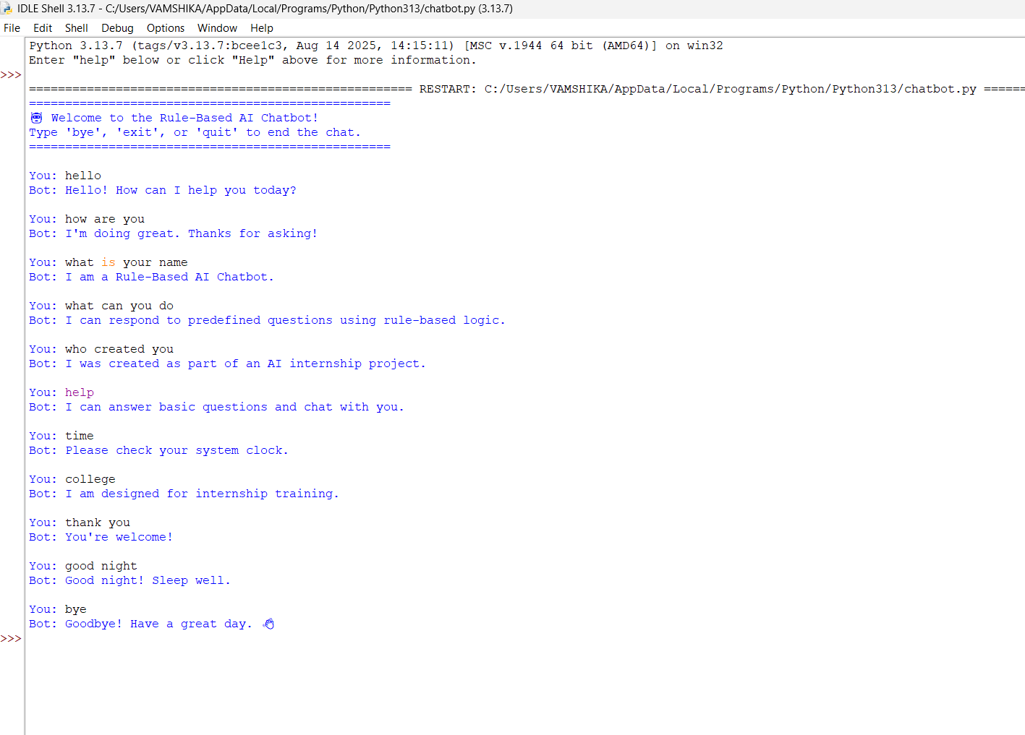
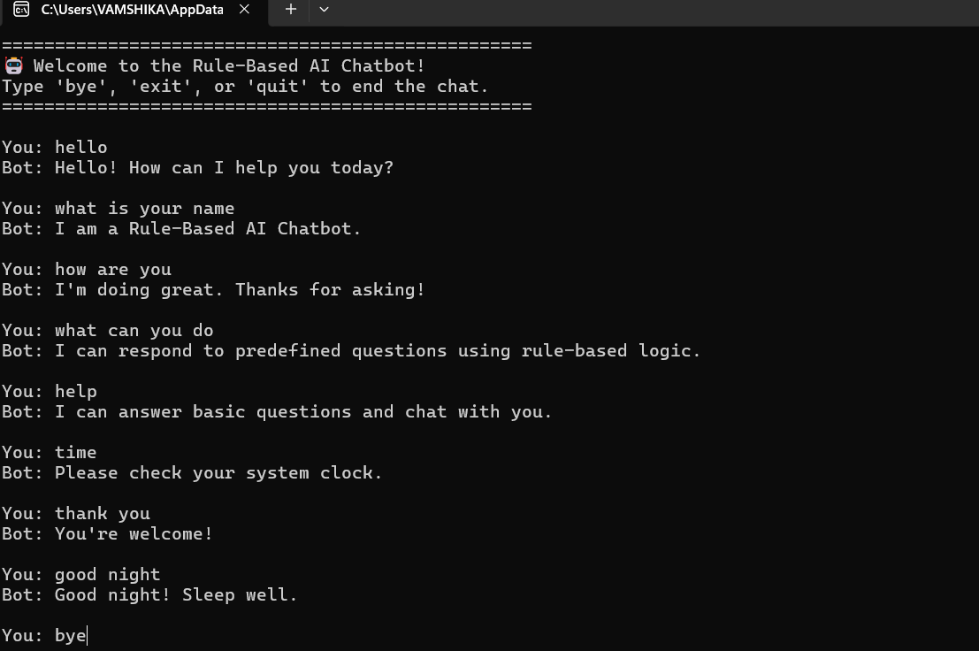

7. Key Concepts Used
- Artificial Intelligence Basics
- Rule-Based Systems
- Dictionary Data Structure
- Control Flow Statements
- Loops
- Conditional Statements
- User Input Handling

8. Advantages
- Easy to implement.
- Fast response generation.
- Suitable for beginners.
- Demonstrates AI fundamentals.
- Can be expanded with additional intents and responses.

9. Limitations
- Cannot learn from users.
- Limited to predefined responses.
- Does not understand complex sentences.
- Requires manual updates for new responses.

10. Conclusion
The Rule-Based AI Chatbot was successfully developed using Python. The chatbot responds to predefined user inputs, handles greetings and exit commands, and runs continuously until the user chooses to terminate the conversation. This project helped in understanding the basic concepts of Artificial Intelligence, decision-making logic, and chatbot development using rule-based techniques.

11. Declaration
I hereby declare that this project work has been completed by me as part of the Artificial Intelligence Internship program and that the work submitted is original and developed using the concepts learned during the internship.
Signature: vamshika.s
Date: 12-06-2026

